# How to Use DDOBuilder

This guide applies to version 1.0.0.85 or later and lists the standard functionality of each of the programs sections.

Contents

How to Use DDOBuilder 1

Introduction 3

Using DDOBuilder 4

The Main Toolbar 5

Menu Commands 6

File Menu 6

Edit Menu 6

Gear Menu 6

Forum Export 6

View Menu 6

Window Menu 6

Help Menu 6

The Main Character View 7

The Equipment View 8

Sentient Weapon and Filigree Selection 9

The Item Select Dialog 10

The Find Gear Dialog 13

Past Lives and Special Feats 14

The Level Up View 16

Choosing your Classes 17

Feat Selection 18

Automatic Feats 19

Granted Feats 19

Spending Skill Points 19

The Skills Dialog 20

Class and Levels View 21

Skills View 23

Enhancements View 24

Reaper Enhancements 26

Epic Destinies 27

Fate Points 28

Twists of Fate 28

Spells View 29

Spell Like Abilities 29

Fixed Spells 30

User Selected Spells 30

Stances View 31

Slider Controlled 31

User Controlled Stances 32

Auto Controlled Stances 32

Tactical DCs View 33

Self and Party Buffs View 34

Notes View 34

Breakdowns View 35

Breakdowns List 35

Contributions List 36

Special Breakdowns 36

Export of Data 37

Abbreviations Used 38

Addendum 38

# Introduction

Welcome to DDOBuilder, a free fan made application for the Standing Stones game “Dungeons and Dragons Online” that allows you to plan and optimise your characters outside of the game environment.

Basic features include:

* Character Creation
  + Name
  + Race
  + Alignment
  + Ability spend
  + Ability Tomes
  + Guild Level
* Feat selection
  + Automatic feats
  + Granted feats
* Skill Points spends
  + Skill Tomes
* Enhancements
  + Racial trees
  + Class specific trees
  + General trees
  + Reaper trees
* Epic Destinies
  + Twists of Fate
  + Destiny tracking
* Past Lives
  + Racial
  + Heroic
  + Epic
  + Iconic
  + Special/Favor (Granted special feats and remnant turn ins)
* Gear
  + All level 20+ gear supported (Not all TOEE supported yet)
  + Augments
  + Sentient Weapon\Minor Artifact Filigrees
* Spells
  + Class spells
  + Granted spells
  + Spell Like Abilities
* Breakdowns
  + Special Attack DCs
  + Many different types with totals and individual contributions listed
* Self and Party Buffs
* Notes
* Export, Clipboard and Forum

# Using DDOBuilder

DDOBuilder is built for ease of use and access to features. All window locations can be user configured using drag/drop and resize functionality.

Your screen layout is saved between runs in the file DDOBuilder.ini which is saved automatically in the same location as the DDOBuilder executable. By default the first time you run DDOBuilder you get a default screen layout optimised for a standard screen display of 1920 by 1080.

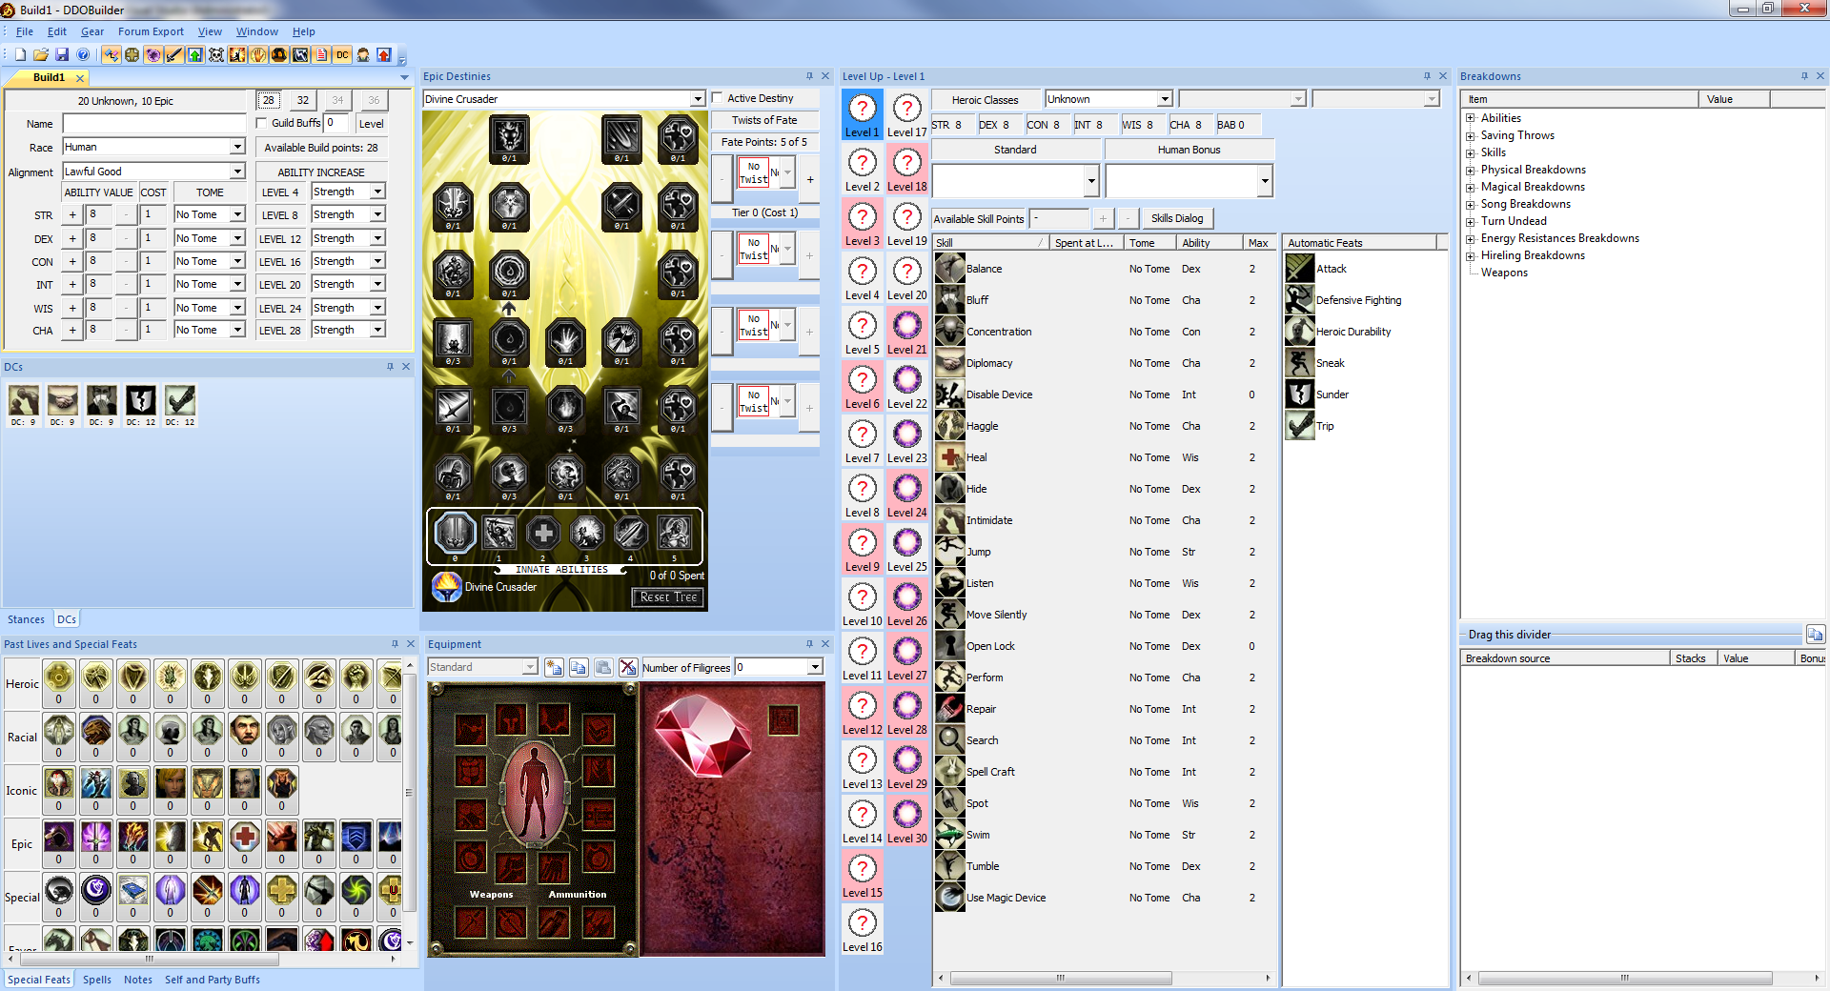

The basic screen layout with a new undefined character created.

DDOBuilder will maintain your character in a valid state for the following features:

* Feat Selections
* Enhancement Selections
* Epic Destiny selections
* Twist of Fate selections
* Gear selections

For example if you have the Feat “Power Attack” trained at level 1, which requires a base Strength of 13 and were to lower your base Strength below 13, then DDOBuilder will revoke the Feat selection and tell you about it in a message box. Note that these revocations can cascade as if “Power Attack” is revoked, which is a requirement for the “Cleave” Feat, that would also be revoked if trained.

Automatic Feat selection is also done for you when only a single Feat selection option is available.

Skill Points are not fully enforced. You can only spend what you have, but changes to Race/Class and Intelligence later can cause your available Skill Points at levels to change.

DDOBuilder also tracks all the effects from your character setup and shows the totals for standard in game attributes and effects.

## The Main Toolbar



The Main Toolbar

The toolbar shown at the top of the screen gives quick access to the following features from left to right:

*  Create a new character
*  Open a previously saved character
*  Save the current character
*  About – Display application version and information
*  Show / Hide the Breakdowns View
*  Show / Hide the Enhancements View
*  Show / Hide the Epic Destinies View
*  Show / Hide the Equipment View
*  Show / Hide the Level Up View (Single level at a time)
*  Show / Hide the Reaper Enhancements View
*  Show / Hide the Past Lives and Special Feats View
*  Show / Hide the Spells and SLAs View
*  Show / Hide the Stances View
*  Show / Hide the Self and Party Buffs View
*  Show / Hide the Notes View
*  Show / Hide the Tactical DCs View
*  Show / Hide the Skill Spend View
*  Show / Hide the Class and Feats View (All levels at the same time)

View display can be toggled on/off as required to hide information you are not interested in at any point. Restoring a view displays it in its previously displayed location.

These toolbar commands are also present in the View menu.

## Menu Commands

The following menu commands are available:

### File Menu

* New Create a new character
* Open Open an existing saved character file
* Close Close the current character file (Prompts to save changes)
* Save Saves the character to its current file
* Save As Saves the character to a file of your choice

### Edit Menu

* Skill points Displays the Skills Dialog
* Reset Build Resets standard character parameters as if you had performed a Heroic, Racial or Iconic TR.
* Development Tools
  + An option used by the developer when updating the software

### Gear Menu

* New Creates a new Gear Set
* Copy Copies the current Gear Set to the clipboard
* Paste Pastes any gear set on the clipboard as a new Gear Set
* Delete Deletes the currently selected Gear Set

### Forum Export

* Export to Clipboard Displays the Export dialog

### View Menu

Various options to show / hide specific windows and choose the application look.

### Window Menu

Lists any open character documents allowing you to switch between them.

### Help Menu

* About DDOBuilder Displays the about box and build information

# The Main Character View

This is the main view that lets you define the starting attributes of your character, Race, Alignment, Tomes and Level ups. It looks like:

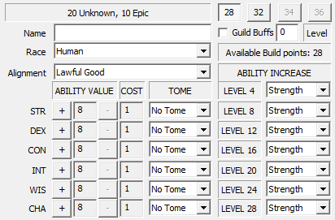

The Main Character View

You can enter and setup the following information:

* The Name of your character
* The Race of your character
* The Alignment of your character – This will affect what Classes are available for selection
* Build points to spend selection
  + With no past lives you can select between 28 and 32 point builds
  + With 1 Heroic/Racial Past life, you automatically get 34 build points
  + With 2 or more Heroic/Racial Past lives you automatically get 36 build points
    - This is 28/30/32 build points for Drow
* Ability point spend, using the [+] and [-] buttons next to the relevant ability
  + Cost of the next [+] buy shown immediately to the right.
* Ability tomes. These can be set individually for each ability or you can use the “Supreme” option in the Strength tome drop list to set all attributes at the same time.
* Ability Level ups. Choose the ability that gets a +1 increase at levels 4/8/12/…, you can also set all at the same time by selection the “All <Ability>” option in the level 4 drop list selection.
* Guild Level and whether guild buffs should be applied to your character. Guild buffs are only applied if this check box is set. You can enter your guild level (0..200).

Your current Class levels are also displayed.

The number of available build points left to be spent are displayed. This can go negative if you spent ability points for a 32/34/36 point build and revoked past lives that qualified you for the additional build point spend.

# The Equipment View

The Equipment View display can be toggled by clicking the button  in the main toolbar.

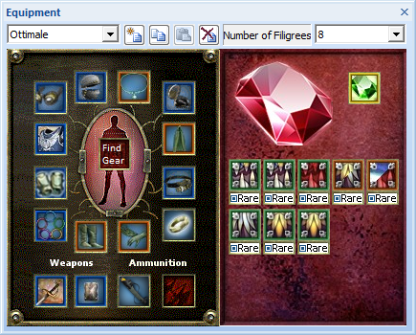

The Equipment View

By default a new character gets a single gear setup called “Standard”. The 4 buttons to the right of the drop list allows the following functions:

*  Create a new Gear set. A dialog is displayed allowing you to name the new Gear Set.
*  Copies the current Gear Set to the clipboard as a private format.
*  Paste a copy of the Gear Set from the clipboard with a new name. This allows you to plan modifications from a current Gear Set without losing your original setup or move Gear Sets between characters. A dialog is displayed to allow you to name the new Gear Set copy.
*  Delete the currently selected Gear Set.

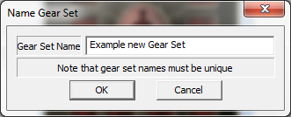

The name new Gear Set dialog

The drop list combo box only becomes active when you have 2 or more Gear Sets for a character defined. Select the Gear Set you wish to view your character for. Only one Gear Set can be active at a time.

To equip or edit an item, left click the equipment slot that you wish to choose an item for. The Item Select Dialog is displayed.

To clear an item, you can right click an equipment slot. This comes with an “Are you sure?” dialog to confirm equipment removal.

Clicking “Find Gear” displays the “Find Gear” dialog which allows you to search and equip items across all accessory slots (not weapon slots).

## Sentient Weapon and Filigree Selection

This section allows you to configure how many Filigree slots you have from your Sentient weapon/Minor Artifact and which Filigrees you have slotted.

Choose how many Filigrees you have in the drop list control. A slot position for each Filigree is displayed. Selecting less Filigrees than you have slotted clears the unwanted Filigrees.

Left click a Filigree position to display a drop list of available Filigrees. A given Filigree can only be equipped once. Once a Filigree has been selected, its “Rare” state can be changed by clicking the  section of the icon.

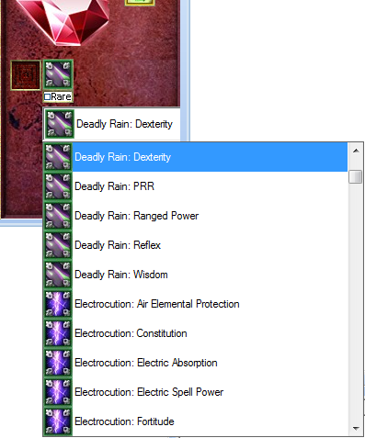

A Filligree selection in progress

You can clear a Filigree by right clicking it.

You can also select the Sentient Jewel type slotted, but this is for cosmetic purposes only.

## The Item Select Dialog

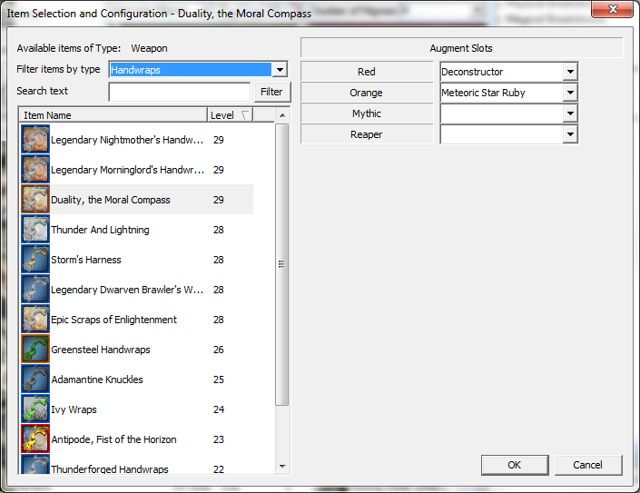

The Item Select Dialog for the Weapon slot

The dialog lists all the available items for the selected equipment slot which your character is eligible for (Items with Class or alignment restrictions are not shown). The item list can be sorted by Name and by Level (Default).

You can enter some filter text that the item(s) listed must contain.

Some equipment slots also allow sub-filtering of the items, this happens for Armor and Weapon equipment slots.

**The currently selected item (if any) is always shown in this list even if it no longer passes the filter selection.**

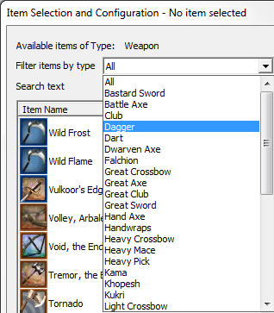

The filter options for a main hand inventory slot.

When selecting Armor, you can filter by Cloth, Light, Medium and Heavy Armor filters. Warforged can only choose from Docents.

When selecting for a Weapon slot, you can filter by weapon type, and for your off-hand also from Shields, Orbs and Rune-Arms. (Note, to select Rune-Arms you must have the Rune-Arm feat trained).

You can hover the mouse over an item in the list to review its basic stats.

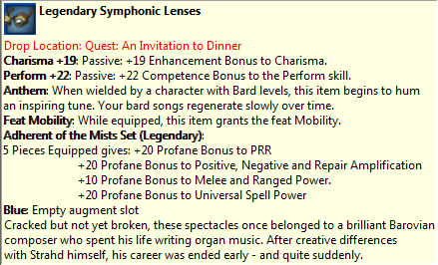

An example item tooltip

To select an item, click on it in the list. This will then become the selected item for that equipment slot if you press OK to end the dialog.

Clicking Cancel will close the dialog without applying any changes made to the selected item (if any).

When an item has been selected you can also configure its Augment slots, Upgrade slots and Special Slots if required.

**Augment Slots:** All items can have regular Augments and optional Mythic and Reaper augments. For these types of augments, select the augment type and enter the value of the augment you have on your item if it does not have a specific value associated with it.

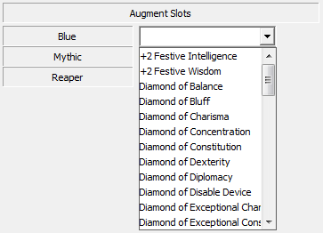

A Blue augment slot with the available list of augments displayed

**Upgrade Slots:** Upgrade slots are specific to the item type. Select from the available list to choose the upgrade to be applied to the item. Once an upgrade slot has been assigned, it can no longer be changed. To recover the choices, you would have to switch to a different item and back to the original item to get the options once again.

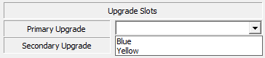

An upgrade slot with its available options displayed

**Special Slots:** Some items are setup to have “Special” named augment slots. This allows you to select a specific variant of a given named item drop that can come with a selection of effects. Crafted items are handled this way also.

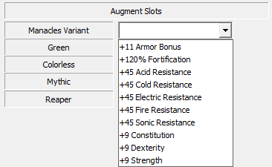

Prisoner’s Manacles with its variant slot drop list displayed

## The Find Gear Dialog

This dialog is displayed when you click on the “Find Gear” icon in the middle of the Inventory view.

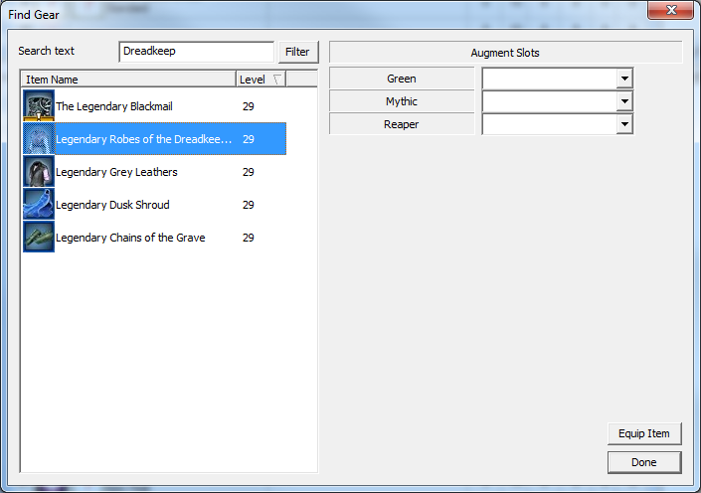

The “Find Gear” dialog with a filter being applied

This dialog allows you to find and equip items across all Accessory slots. By default all items (except for weapon slot items) that you qualify to equip are displayed. This dialog works almost exactly the same at the Item Select Dialog.

Enter search text to limit the items displayed. For example, if you wanted to find all the “Dreadkeeper” set items you can enter appropriate filter text.

To equip an item, select it in the list and click the “Equip Item” button. The item will be equipped into the relevant slot in the current active equipment set.

If the item can equip to multiple different slots, a popup menu for target slot location is displayed.

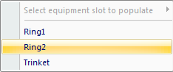

Popup menu displayed for an item that can equip to 3 different slots

# Past Lives and Special Feats

The Past Lives and Special Feats View display can be toggled by clicking the button  in the main toolbar.

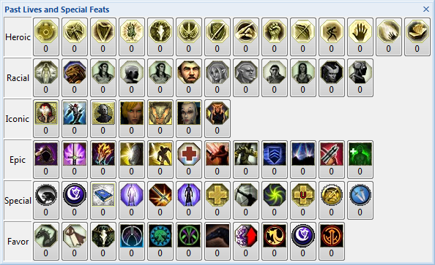

The Past Lives and Special Feats View

This view allows you to configure the Past Lives and Special feats your character has acquired.

Past Lives are split into sections depending on type. Each Past Life type can be trained a set number of times. Special feats have their own maximum acquire count.

* Heroic – Gained from Heroic True Reincarnation and Iconic True Reincarnation
* Racial – Gained from Racial True Reincarnation
* Iconic – Gained from Iconic Reincarnation
  + Note that you have to select the Heroic feat associated with your main Class yourself
* Epic – Gained from Epic Reincarnation
  + Training Epic past lives will auto award Fate Points at relevant tiers
* Special –Special Feats such as Inherent bonuses from Remnant turn in or Tomes of Fate. Also options for Enhancement Trees acquired through store purchases or previous lives
* Favor – Favor reward bonuses from various factions

To train a Feat, click it with the left mouse button. To revoke a trained Feat, right click it.

The number of times the Feat has been trained is displayed immediately under the Feat icon.

Mouse over a Feat button to see what bonus’s that Feat awards you.

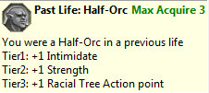

The bonuses associated with the Racial Half-Orc past life Feat

Past life Feats affect the number of build points you have available for ability selection in the Main Character View.

**Some special feats will change which Enhancement Trees you have available (Inquisitive, Harper Agent, Falconry and Vistani)**

# The Level Up View

The Level Up View display can be toggled by clicking the button  in the main toolbar.

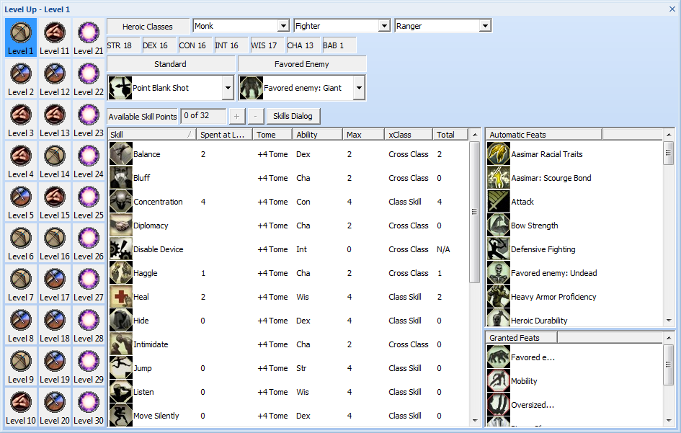

An Example of the Level Up View

The Level Up View allows you to select Classes, Feats and spend Skill Points for each of the 30 levels that your character can train, one level at a time.

The controls available include:

* A button for each level you can train. The selected level has a blue background
  + A pink background shows that you either have an untrained Feat for that level or a problem with that level (e.g. an overspend of Skill Points)
* The Heroic Classes that your character can select from
  + Any character can have a maximum of 3 different Heroic Class types. Select the Classes you want using the drop list combos at the top of this screen
  + Note that the available Classes will be limited by your current Alignment
* Your base Ability and BAB values at the selected level. These values include Ability tomes and level up selections and Class contributions for BAB.
* Drop list Feat selection combo boxes
  + These lists are filtered to selectable Feats only
* Controls to spend Skill Points and display current skill values.
  + You can also pop up the skills dialog to spend Skill Points across all levels.
* A list of all the automatically acquired Feats for the currently selected level.
* A list of any Granted Feats from enhancements and equipment.

## Choosing your Classes

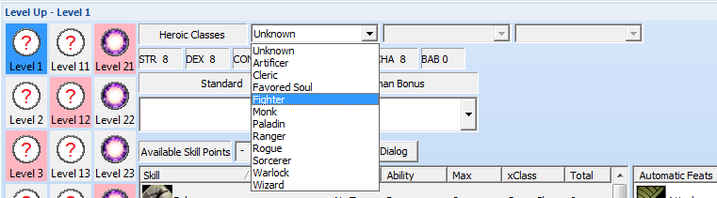

Class Selection drop list displayed

For a new character only the first drop list control is available.

* The Classes listed in this control are limited by your Alignment

Once a Class has been selected, you will be able to choose your next Class option:

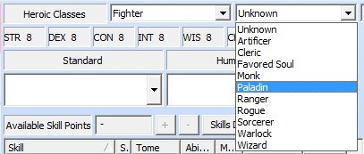

Second Class selection available after first Class selected.

This works the same for the third Class selection also.

Setting a previously selected Class to “Unknown” will clear that Class from any trained levels. Feats, Enhancements and Destiny selections may/will be revoked by doing this.

When you select a class choice, all levels currently set to “Unknown” will be set to that class type.

Changing a class selection, will change all levels of the previous class to the new class.

Once you have your Class selections, you can set which Class is trained at a given level by selecting that level via its level button and then left clicking that button once again to display a Class select pop-up menu:

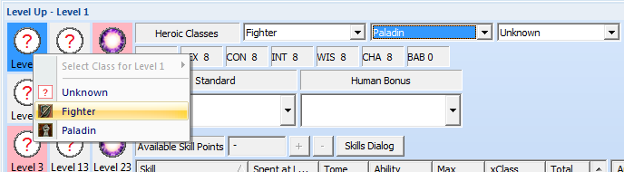

Class selection for level 1 from the list of selected heroic Classes

*Note: For Iconic races, DDOBuilder does not enforce specific Class requirements for level 1 as these can be changed by a +X Heart of Wood in game. You will however get a warning in the level 1 tooltip and the forum export output.*

Setting a specific levels Class will update the available Feats for that level and may invalidate current Skill Point spends (if any).

## Feat Selection

Each Heroic and Epic level may have Feat selection(s) available. These are displayed as drop list combo boxes at the top of the screen with a label above saying what type of Feat selection it is.

There can never be more than 3 Feat selection options at any given level.

The available Feats in the list are automatically filtered by the following criteria to only show ones you qualify to train:

* Your current level
* Your base Ability values at the current level (Shown above the feat selection combo boxes)
* Your current BAB
* Any previous required Feat prerequisites
* The Feat slot type
* Your current Classes and Class levels

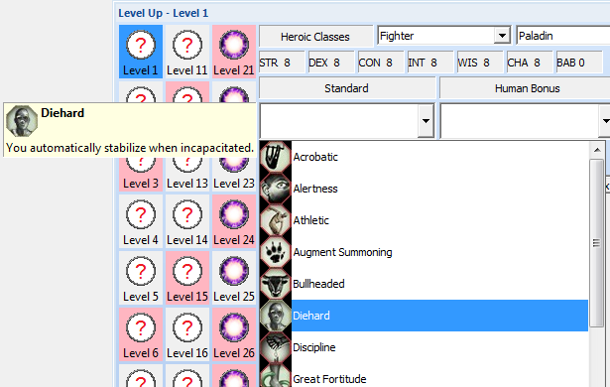

An open Feat Selection drop list for a Standard Feat selection at level 1

Note that during Feat selection a tooltip is displayed beside the combo box to allow you to review the Feat information.

Select a Feat from the drop list to train that Feat. To clear a previously trained feat, select the first option of “No Selection”.

## Automatic Feats

This control lists any automatically acquired Feats at this level. You can mouse over them in the control to get a description of their effects.

## Granted Feats

This control lists any Granted Feats from equipment or enhancements. You can mouse over them in the control to get a description of their effects.

## Spending Skill Points

The Skill Points you have available at the selected level are displayed, the number of which are dependent on your Class, Race and Intelligence modifier.

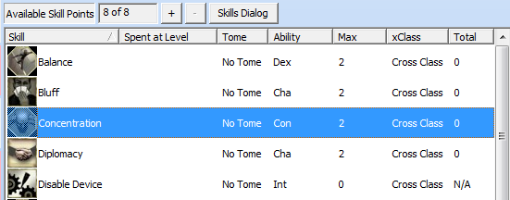

Skills list for a Fighter at Level 1

Skill points can only be trained once you have a Class set for the selected level.

The columns in this control are:

* Skill – The name of the Skill
* Spent at Level – The number of Skill Points you have trained in this skill at this level
* Tome – The Skill Tome your character has for this Skill. Double click this field to set the Skill Tome value
* Ability – The Ability which gives a bonus to this skills total
* Max – The maximum Skill ranks this skill can have at this level
* xClass – Whether the Skill is a Cross Class (½ skill rank per Skill Point) or a Class skill (Full rank per Skill Point)
* Total – The total Ranks trained in this skill for all levels up to and including the current level.
  + This total can be “N/A” for special skills such as Open Locks and Disable Device as you have to have Rogue or Artificer levels to be able to train these skills.

To train a skill, select it in the Skills list and click the [+] or [-] buttons.

These buttons will be enabled when you can spend Skill Points and disabled when you cannot.

To spend Skill Points across all levels at the same time, click the [Skills Dialog] button.

## The Skills Dialog

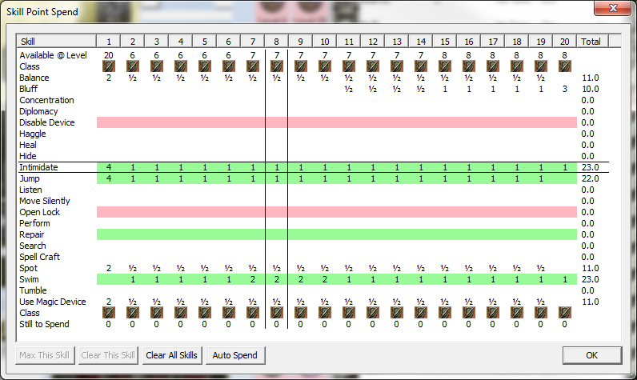

Example Skills dialog for a 20th Level Fighter

This dialog allows you to set your Skill Point spends for all your Heroic levels at the same time.

Move your mouse over the dialog to select the level and Skill to train. This is shown by selection lines around the Skill and level.

* To train a skill rank at that level left click that location, to revoke a skill rank, right click that location
* Class skills are shown with a Green background
* Cross Class skills have a White background
* Non-trainable skills are shown with a Red background
* Overspend in a skill is shown by the numbers appearing in RED

The top two line shows the total number of Skill Points you have available at that level and the icon of the Class selected at that level.

The bottom two lines show the Class selected and the number of unspent Skill Points at that level.

There are four special options available via buttons at the bottom of the dialog:

* [Max This Skill] – The selected skill will have Skill Points automatically assigned to it where available to try and attain the maximum ranks possible at Heroic level 20
* [Clear This Skill] – All Skill Points assigned to this skill at all levels are revoked
* [Clear All Skills] – All spent Skill Points at all levels are revoked
* [Auto Spend] – DDOBuilder applies an auto spend (i.e. a Max This Skill action) on skills selected for you by a weighting scheme based on your Class selections. It does this until you have no more Skill Points to spend

Changes made in this dialog apply to your character as they are done.

**This Dialog will be removed at a later date due to the introduction of the Skills view.**

# Class and Levels View

The Class and Levels View display can be toggled by clicking the button  in the main toolbar.

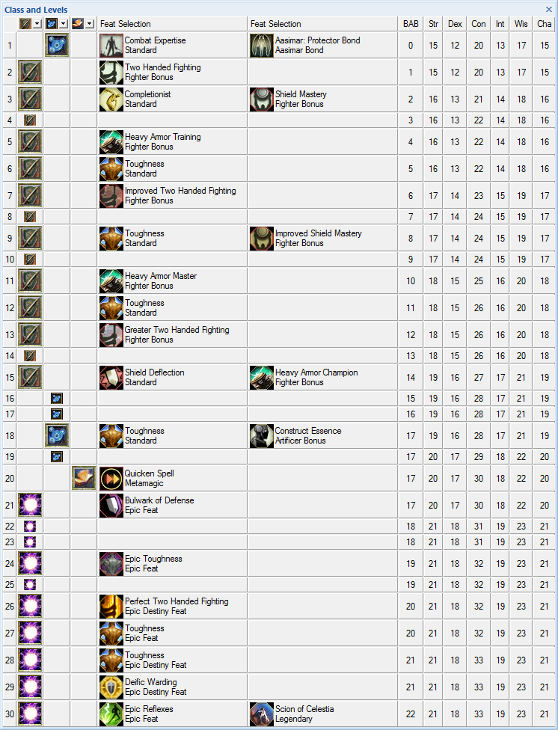

The Class and Level view for a character with 3 classes

This view allows you to set all your class levels and feats at the same time.

Use the class drop lists available at the top left of the view to select the classes your build requires. Note that the available classes is limited by your currently selected Alignment.

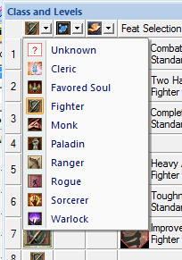

Class Selection Menu displayed during class selection

Once you have at least 1 class selected, you will be able to select additional classes up to a maximum of 3.

When you select a class choice, all levels currently set to “Unknown” will be set to that class type.

Changing a class selection, will change all levels of the previous class to the new class.

When you have your classes selected, you can set the class you want at any specific level by clicking on that levels class column. The currently trained class for that level has the class icon displayed.

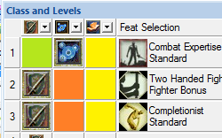

Areas to click to set a class selection

In this picture, clicking the green area would set level 1 to the Fighter class, the Orange regions would set the relevant levels to the Artificer class and the yellow to the Wizard class.

As class selections are made, available feat slots are updated. To save on screen real-estate, class levels with no available feat selections are shown half size.

To select or change a feat, left click that feat option and a drop list combo box will be displayed with available feat selections. When changing a feat the currently selected feat will start selected by default.

The control also shows the base BAB and Ability values your build has at the given level, as these values can explicitly affect which feat selections are available.

You can mouse over a selected feat or class section to get access to a tooltip.

# Skills View

The Skills view display can be toggled by clicking the button  in the main toolbar.

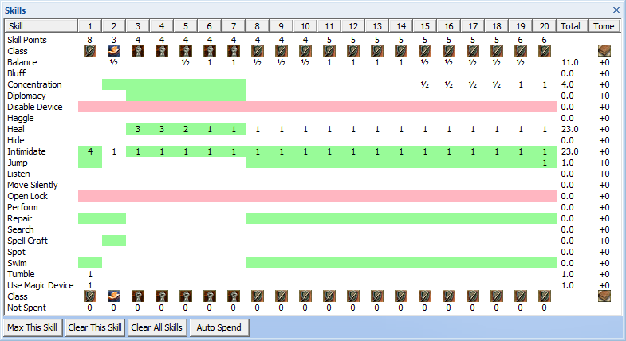

Example Skills dialog for a multiclass tank

This view allows you to set your Skill Point spends for all your Heroic levels at the same time.

Move your mouse over the dialog to select the level and Skill to train. This is shown by selection lines around the Skill and level.

* To train a skill rank at that level left click that location, to revoke a skill rank, right click that location
* Class skills are shown with a Green background
* Cross Class skills have a White background
* Non-trainable skills are shown with a Red background
* Overspend in a skill is shown by the numbers appearing in RED
* The Tome column allows you to set the skill tome you have for a given skill

The top two line shows the total number of Skill Points you have available at that level and the icon of the Class selected at that level.

The bottom two lines show the Class selected and the number of unspent Skill Points at that level.

There are four special options available via buttons at the bottom of the dialog:

* [Max This Skill] – The selected skill will have Skill Points automatically assigned to it where available to try and attain the maximum ranks possible at Heroic level 20
* [Clear This Skill] – All Skill Points assigned to this skill at all levels are revoked
* [Clear All Skills] – All spent Skill Points at all levels are revoked
* [Auto Spend] – DDOBuilder applies an auto spend (i.e. a Max This Skill action) on skills selected for you by a weighting scheme based on your Class selections. It does this until you have no more Skill Points to spend

# Enhancements View

The enhancements view display can be toggled by clicking the button  in the main toolbar.

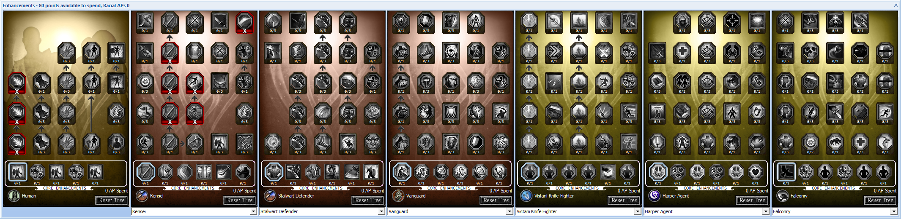

The Enhancements View for a Level 20 Fighter

This view allows you to select and train enhancements by spending Racial, Universal and regular Action Points.

The number of available Racial, Universal and regular Action Points are shown in the windows title bar.

**Some special feats will change which Enhancement Trees you have available (Inquisitive, Harper Agent, Falconry and Vistani), please check that view if you do not have access to an expected tree.**

All characters can have a maximum of 7 enhancement trees. One Racial tree, and 6 Class/Universal trees. If the tree you want is not one of the 7 you can choose it using the drop list combo boxes displayed under the Class/General tree options:

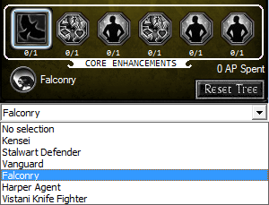

A tree with the available tree selection drop list displayed

Selecting a new tree will switch out the current tree selection. The current tree can only be switched out if no Action Points have been spent in it.

The Class and Universal trees can be re-ordered using drag and drop of the tree icon. To switch the order click and drag a tree icon onto another tree. Those trees will be swapped.

Any given enhancement tree can have the following actions done:

* Left click a highlighted icon to train that enhancement
  + Can only be done on enhancements with a white highlight border
* Right click the tree to revoke the last trained enhancement in this tree
  + This can be done until all trained enhancements are revoked
* Mouse over an enhancement to get a description of its effects
* Reset all Action Points spent in this tree
* Middle click the tree to copy the displayed bitmap to the clipboard

Individual tree enhancements can have:

* Multiple ranks, each to be bought separately

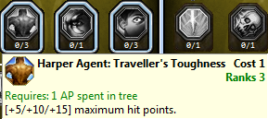

An untrained enhancement with multiple ranks

* Additional requirements, such as required trained Feats to be selected

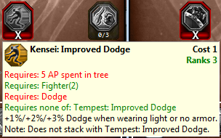

An enhancement with a trained Feat requirement

* A multiple select option dialog when choosing a variant of a specific enhancement

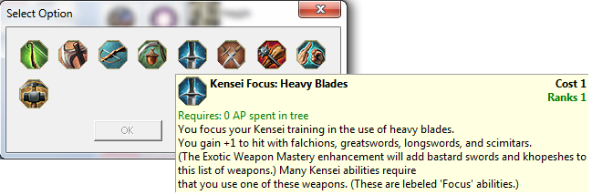

An enhancement with a multi-selector

Options in the multi-selector dialog may be disabled if you do not meet the individual requirements for them.

Multi-selectors for item not yet trainable can also be reviewed. The dialog will be displayed with all items disabled.

# Reaper Enhancements

The Reaper Enhancements View display can be toggled by clicking the button  in the main toolbar.

The Reaper Enhancements View works exactly the same as regular enhancement trees except that there is no limit on points spent, and the effects only apply if Reaper stance is active1.

The view title will also display how much reaper xp is required for the number of spent reaper points.

1 Some Reaper core effects always apply outside of Reaper mode.

# Epic Destinies

The Epic Destinies View display can be toggled by clicking the button  in the main toolbar.

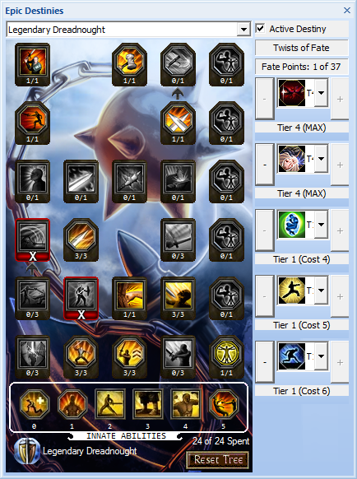

The Epic Destinies View for an end game character with Epic Completionist

The Epic Destinies View allows you to configure your active destiny, spend Fate Points and select Twists of Fate.

Only one Destiny tree can be active at a time. By default this view shows your active tree (if any).

Select the Epic Destiny you wish to spend points in using the drop list combo box. You can spend points in any Destiny at any time, although only the enhancements in the active Destiny will be applied to your character.

You can have a maximum of 24 Destiny Points to spend in a Destiny tree, but by default you have no points to spend until you level up the Destiny tree. This is done by selecting the free Destiny core innate ability options in the tree, which mimics how destiny points are awarded via destiny xp in game.

Destiny tree enhancements are acquired and revoked exactly the same way as standard Enhancements.

## Fate Points

Fate Points are automatically made available depending on:

* The number of Epic past lives you have
* The number of trained Innate Abilities in each of the Destiny trees
* Any Tomes of Fate in the Past lives and Special Feats View

## Twists of Fate

Twists of Fate can be levelled up as they are in game by using the [+] and [-] buttons on each twist:

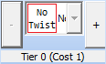

An Untrained Twist of Fate

The current tier of the Twist is displayed, along with the cost in Fate Points to upgrade the Twist to the next tier.

The number of available and spent Fate points is also displayed.

You cannot train a Twist to a higher level than a previous Twist in your Twist list.

A fifth Twist is automatically listed if you quality for Epic Completionist.

To select a Twist of Fate, the relevant enhancement from the Destiny you want to train it from must be trained in that tree. Click the drop list and you will be presented with a list of available trained Destiny enhancements from the non-active trees up to the available Twist tier:

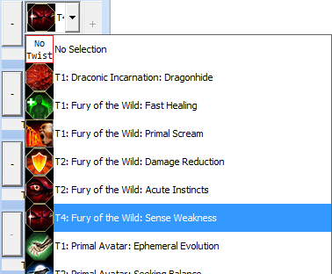

A Tier 4 Twist and its available list of selectable enhancements

Revoking a trained Twist from the relevant Destiny will cause a revocation of the Twist of Fate.

# Spells View

The Spells view display can be toggled by clicking the button  in the main toolbar.

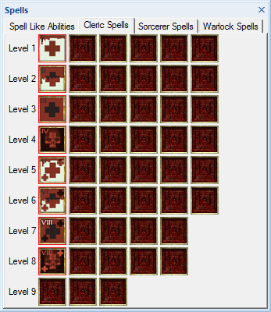

The Spells View for a character with Cleric, Sorcerer and Warlock levels

The Spells View shows any Spell Like Abilities (SLA) and Class specific spells you have due to your Class levels.

A tab for each spell casting Class you have will be available. All characters gain access to the SLA tab.

Spells come in two varieties:

1. User selectable spells
2. Fixed spells

Spells in the control are always listed alphabetically from left to right. Fixed spells are always shown first.

## Spell Like Abilities

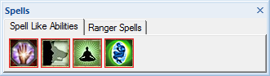

A character with SLAs

Any SLAs granted through Feats, Enhancements and Gear will be listed. You can mouse over these SLAs to get a description of them.

## Fixed Spells

Fixed spells are spells you gain at a specific level for your Class, such as Clerics automatically gain the standard cure spells at each spell level. Fixed spells are shown with a red border and cannot be changed.

Some Classes’ award fixed spells based on Enhancement selections, such as Warlocks. These spells are automatically added to the relevant spell level section when they become available.

## User Selected Spells

To select/change a spell, left click the spell slot and a drop list of available spells at that level will be displayed:

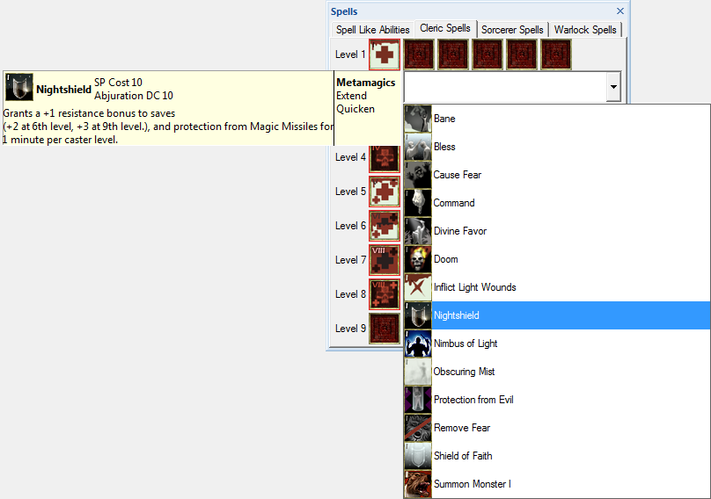

Spell selection for a Cleric level 1 spell

A tooltip is displayed while spell selection is in progress. The same tooltip is shown when you mouse over an already selected spell.

The tooltip allows you to see the spell DC, Spell Point cost and available metamagics that can be applied to the spell in question.

# Stances View

The Stances View display can be toggled by clicking the button  in the main toolbar.

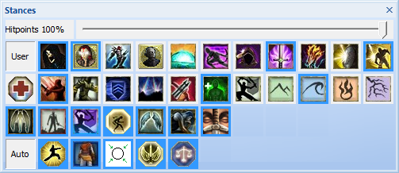

The Stances View for a character with many available options

The Stances View allows you to configure the states of enhancements and abilities that can be optionally enabled or disabled.

Stances come in three varieties:

* Slider Controlled – The slider position decides the number of stacks of a given effect or applies logic to enable/disable a special stance such as “Current Hitpoints < 80%”
* User Controlled – You decide whether the stance is enabled or disabled
* Auto Controlled – DDOBuilder enables or disables the stances automatically based on equipped gear and selected enhancements where appropriate

## Slider Controlled

Sliders can control how effects apply in one of two ways:

1. The slider directly controls how many stacks of a given effect you have
2. The slider defines the value of a special stance such as your current Hitpoints, effects can be setup to toggle on/off depending on the current slider position

Breakdowns will update as required as slider values are changed. Slider values are not saved with your character and have to be changed each time you open the character file.

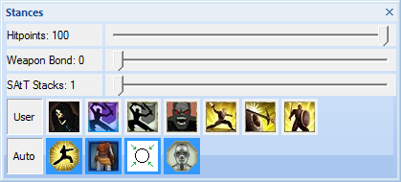

A character with multiple sliders available

## User Controlled Stances

Enabled stances have a blue border, while disabled stances have no border.

Mouse over a stance to get a description of it.

Left click a stance button to toggle its state.

Some user controlled stances are mutually exclusive, for example, a Monk can only have one of Wind, Water, Earth or Fire stance active at a time. Enabling a stance that is exclusive will automatically disable the other stances for you.

User controlled stances are automatically added to this section as they become available. For example, training an Epic Past life will make the relevant Active Past Life stance be listed.

When a stance is active, relevant effects that apply when the stance is active will be listed in the Breakdowns View and totals will be updated.

## Auto Controlled Stances

DDOBuilder will set the states of these stances for you automatically based on your equipped gear and selected enhancements.

Mouse over an Auto controlled stance to get a description of it.

Only Active Auto controlled stances are shown.

# Tactical DCs View

The DCs View display can be toggled by clicking the button  in the main toolbar.

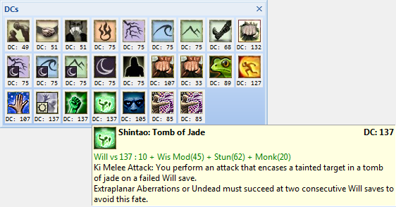

The DCs View with a tooltip displayed

The DCs view shows you an icon for each physical DC type attack/effect you have.

These are added/removed dynamically from the view as they are acquired/lost.

You can mouse over an icon to see the DC value and how the DC is calculated for that action.

# Self and Party Buffs View

The Self and Party Buffs View display can be toggled by clicking the button  in the main toolbar.

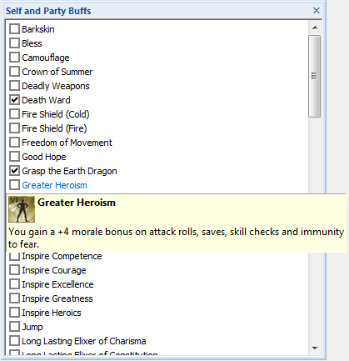

Example Self Buffs View with selected buffs and a tooltip displayed

The Self and Party Buffs View allows you to configure which of common buffs you play with for your character. Apply checkmarks against those buffs that you will have on your character.

Effects will be applied or revoked as required and the breakdowns will update where appropriate.

# Notes View

The Notes View display can be toggled by clicking the button  in the main toolbar.

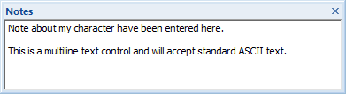

An example notes view with some text

The Notes view allows you to enter free format standard ASCII text. These Notes are saved with your character and allow you to keep information about character with the character build.

# Breakdowns View

The Breakdowns View display can be toggled by clicking the button  in the main toolbar.

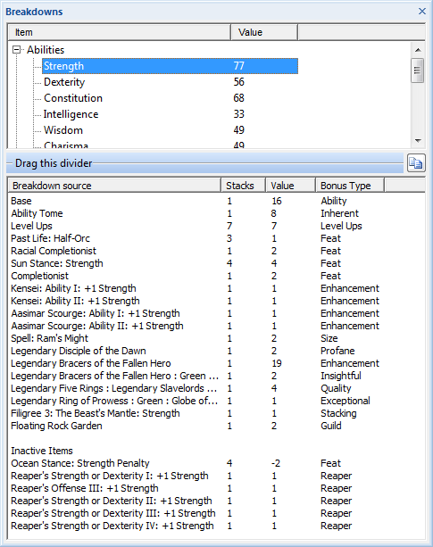

Example content for the Strength breakdown for an end game build

The Breakdowns View allows you to view the total values for many different in game parameters.

Some of the listed breakdowns are Gear specific and will be added or removed depending on your selected gear (Weapon breakdowns).

## Breakdowns List

The current total value of a given breakdown is displayed in a tree structure. Expand or contract the tree elements to review the breakdown totals.

To find out how a given breakdown total was achieved, click the item in question and all the contributions to that breakdown will be listed.

## Contributions List

This control shows all the individual contributions and their sources that apply to the selected breakdown.

The  copy button will place a table of the breakdowns contributions on the clipboard as text. For example:

[font=courier]

· · · · · · · · · · · · · · · · · · · · · · · · · · · · · · · · ·Wisdom · · · · · ·100· · · · · · ·

· · · · · · · · · · · · · · · · · · · · · · · · · · · ·Breakdown source ·Stacks ·Value· ·Bonus Type

· · · · · · · · · · · · · · · · · · · · · · · · · · · · · · · · · ·Base · · · 1 · · 18· · · Ability

· · · · · · · · · · · · · · · · · · · · · · · · · · · · Racial Modifier · · · 1 · · ·2· · · ·Racial

· · · · · · · · · · · · · · · · · · · · · · · · · · · · · ·Ability Tome · · · 1 · · ·8· · ·Inherent

· · · · · · · · · · · · · · · · · · · · · · · · · · · · · · · Level Ups · · · 7 · · ·7· · Level Ups

· · · · · · · · · · · · · · · · · · · · · · · · · · ·Past Life: Aasimar · · · 3 · · ·1· · · · ·Feat

· · · · · · · · · · · · · · · · · · · · · · · · · · · ·Past Life: Human · · · 3 · · ·1· · · · ·Feat

· · · · · · · · · · · · · · · · · · · · · · · · · ·Ocean Stance: Wisdom · · · 4 · · ·4· · · · ·Feat

· · · · · · · · · · · · · · · · · · · · · · · · · ·Racial Completionist · · · 1 · · ·2· · · · ·Feat

· · · · · · · · · · · · · · · · · · · · · · · · · · · · · Completionist · · · 1 · · ·2· · · · ·Feat

· · · · · · · · · · · · · · · · · · · · · Aasimar: Ability I: +1 Wisdom · · · 1 · · ·1· Enhancement

· · · · · · · · · · · · · · · · · · · · ·Aasimar: Ability II: +1 Wisdom · · · 1 · · ·1· Enhancement

· · · · · · · · · · · · · · · · · · · · · · Falconry: Ability I: Wisdom · · · 1 · · ·1· Enhancement

· · · · · · · · · · · · · · · · · · · · · ·Falconry: Ability II: Wisdom · · · 1 · · ·1· Enhancement

· · · · · · · · · · · · · · · · · · · · · Shintao: Ability I: +1 Wisdom · · · 1 · · ·1· Enhancement

· · · · · · · · · · · · · · · · · · · · ·Shintao: Ability II: +1 Wisdom · · · 1 · · ·1· Enhancement

· · · · · · · · · · · · · · · · · · · · · · Shintao: To Seek Perfection · · · 1 · · ·4· Enhancement

· · · · · · · · · · · · · · · · · · · · Reaper's Arcanum III: +1 Wisdom · · · 1 · · ·1· · · ·Reaper

· · · · · · · · · · · · · ·Grandmaster of Flowers: Ability I: +1 Wisdom · · · 1 · · ·1· · · Destiny

· · · · · · · · · · · · · Grandmaster of Flowers: Ability II: +1 Wisdom · · · 1 · · ·1· · · Destiny

· · · · · · · · · · · · · · · · · · · · ·Legendary Disciple of the Dawn · · · 1 · · ·2· · · Profane

· · Cannith Crafted Goggles : Cannith Goggles Extra : Insightful Wisdom · · · 1 · · ·7· ·Insightful

· · · · · · · · · · · · · · · · · · · · · · · · · · ·Fleetfoot Necklace · · · 1 · · 20· Enhancement

· · · · · · Legendary Five Rings : Green : Globe of True Imperial Blood · · · 1 · · ·1· Exceptional

· Legendary Five Rings : Legendary Slavelords Bonus : Quality Wisdom +4 · · · 1 · · ·4· · · Quality

· · · · · · · · · · · · ·Echo of Ravenkind : Yellow : +2 Festive Wisdom · · · 1 · · ·2· · · Festive

· · · · · · · · · · · · · · · · · · · · · · · · · ·Floating Rock Garden · · · 1 · · ·2· · · · Guild

· · · · · · · · · · · · · · · · · · ·Yugoloth: Essence of Despair (Wis) · · · 1 · · ·2· · ·Stacking

· · · · · · · · · · · · · · · · · · · · · Long Lasting Elixer of Wisdom · · · 1 · · ·2· · ·Stacking

· · · · · · · · · · · · · · · · · · · · · · · · · · · · · · · · · · · · · · · · · · · · · · · · · ·

· · · · · · · · · · · · · · · · · · · · · · · · · · · · ·Inactive Items · · · · · · · · · · · · · ·

· · · · · · · · · · · · · · · · · · · · · · ·Sun Stance: Wisdom Penalty · · · 4 · · -2· · · · ·Feat

· · · · · · · · · · · · · · · · · · · · ·Reapers's Ability I: +1 Wisdom · · · 1 · · ·1· · · ·Reaper

· · · · · · · · · · · · · · · · · · · · ·Reaper's Ability II: +1 Wisdom · · · 1 · · ·1· · · ·Reaper

· · · · · · · · · · · · · · · · · · · · Reaper's Ability III: +1 Wisdom · · · 1 · · ·1· · · ·Reaper

[/font]

Stacking rules for items are automatically applied because of this items can be:

* Active – Applies to and added to the current total
* Inactive – A bonus will only apply when the relevant stances are active, e.g. the Ocean stance Strength penalty only applies if the character is in Ocean stance
* Non-stacking effects – If you have the same bonus type from multiple sources, only the highest value applies. Any effects that do not apply due to the stacking rules are listed

## Special Breakdowns

Some breakdowns act slightly differently to standard numeric breakdowns, such as Immunities and DR (Damage Reduction). These just list specific items.

# Export of Data

You can access the export dialog by selecting the “Forum Export\Export to Clipboard” command from the menu. The following dialog is displayed:

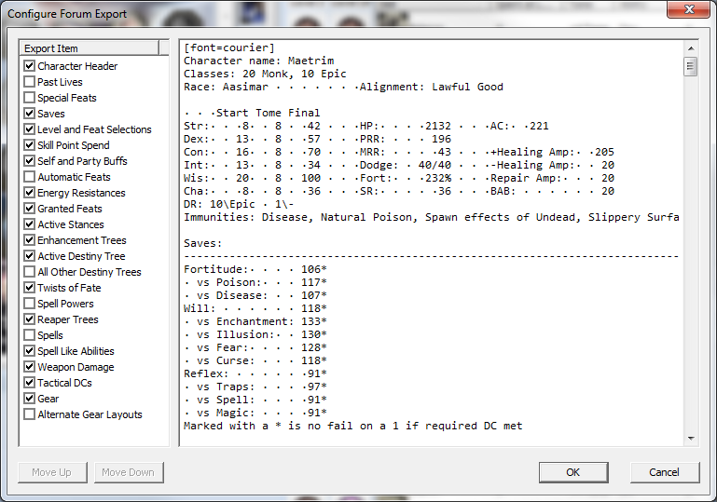

Forum Export Configuration Dialog

This dialog allows you to configure the sections of data that you want to copy to the clipboard as text.

Place checkmarks against items you want in the export, and remove those you do not want.

You can re-order the export items by selecting an item in the left hand list and using the [Move Up] and [Move Down] buttons.

The enabled/disabled state and order of these items are retained between runs and will be the same next time you use the export functionality.

The control on the right shows the data that will be copied to the clipboard on an [OK] of this dialog.

Clicking [Cancel] does not copy anything to the clipboard.

This data is editable, but any changes you make to it will be lost if you change the display state or order of any item. Changes are not kept between dialog runs either.

# Abbreviations Used

A list of any abbreviations and acronyms used in this document:

AP Action Point

BAB Base Attack Bonus

DC Difficulty Check

DDO Dungeons and Dragons Online

DR Damage Reduction

SLA Spell Like Ability

SSG Standing Stone Games

TOEE Temple of Elemental Evil

# Addendum

The DDOBuilder application is provided as is with no warranty of any kind.

Use at your own risk.

The Author of this program is in no way a representative of Standing Stone Games, just a long time player.

Many thanks go to those who edit the [DDOWiki](http://ddowiki.com/page/Home) from which large amounts of the data for this program was obtained.

Please report any bugs, comments or suggestions in the main DDO thread or directly at the GitHub project:

[GitHub Repository](https://github.com/Maetrim/DDOBuilder) - <https://github.com/Maetrim/DDOBuilder>

[DDO Forums thread](https://www.ddo.com/forums/showthread.php/487211-DDO-Character-Planner) - <https://www.ddo.com/forums/showthread.php/487211-DDO-Character-Planner>

Maetrim of Cannith